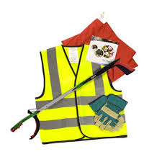
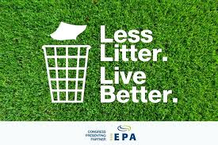
The Parish Spring Clean is back!
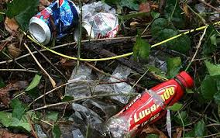
Have you had enough of other people’s litter?
Are you willing to do something about it?
Then join us on: Friday 29th March 2019, 9am
Meet at: Needingworth Village Hall
Holywell-cum-Needingworth Parish Council are looking for volunteers to take part in the annual Parish Spring Clean
Following the massive success of Clean for the Queen and the Great British Spring Clean over the last few years please join us to help clear our village of litter, together we can make a difference. If you require any further information please contact the Parish Council Office on tel: 01480 468451 or email: acneedingworthpc@btconnect.com

